Identificación de elementos en página web.

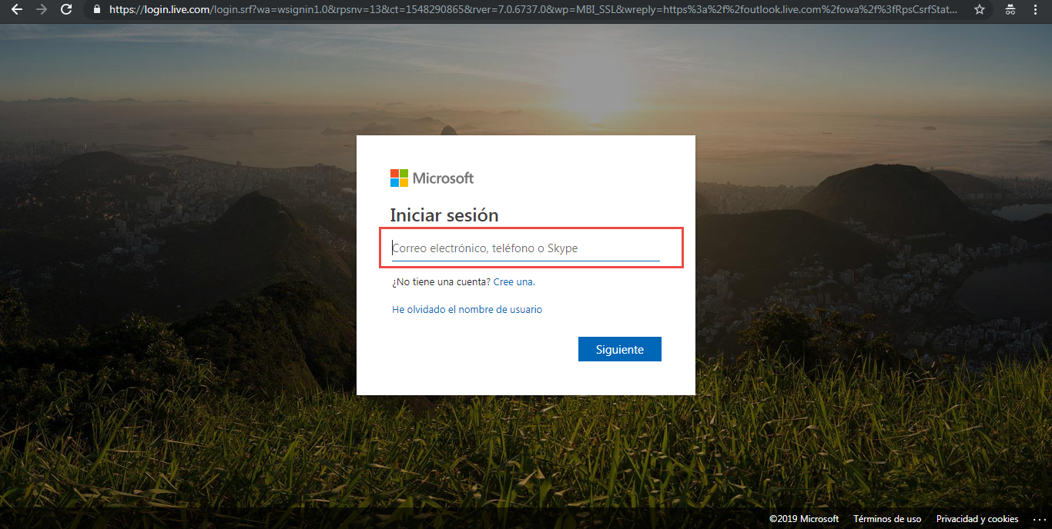

Se identifican los:

* **Elementos**
* **Atributos**

<**input type**="email" **name**="loginfmt" **id**="i0116" **maxlength**="113" **lang**="en" **class**="form-control ltr_override" **aria-describedby**="usernameError loginHeader loginDescription" **aria-required**="true" **data-bind**="textInput: usernameTextbox.value,

hasFocusEx: usernameTextbox.focused,

placeholder: $placeholderText,

ariaLabel: tenantBranding.UserIdLabel || str['CT_PWD_STR_Username_AriaLabel'],

css: { 'has-error': usernameTextbox.error },

attr: inputAttributes" placeholder="Correo electrónico, teléfono o Skype" **aria-**label="Escriba su correo electrónico, teléfono o Skype.">

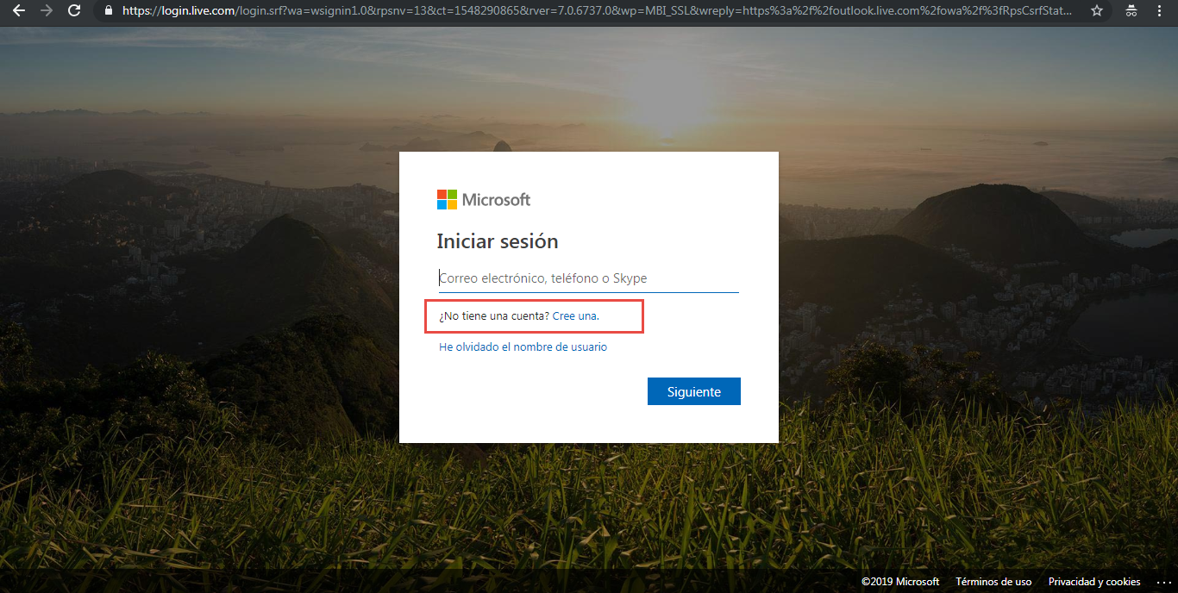<**a href**="https://signup.live.com/signup?wa=wsignin1.0&amp;rpsnv=13&amp;ct=1548301768&amp;rver=7.0.6737.0&amp;wp=MBI_SSL&amp;wreply=https%3a%2f%2foutlook.live.com%2fowa%2f%3fnlp%3d1%26RpsCsrfState%3d747d6c45-6159-5493-f726-38b9ba2091f0&amp;id=292841&amp;aadredir=1&amp;CBCXT=out&amp;lw=1&amp;fl=dob%2cflname%2cwld&amp;cobrandid=90015&amp;contextid=DC4666BA2EC4C92D&amp;bk=1548301768&amp;uiflavor=web&amp;mkt=ES-ES&amp;lc=3082" **id**="signup" **aria-label**="Crear una cuenta Microsoft">Cree una.<**/a**>

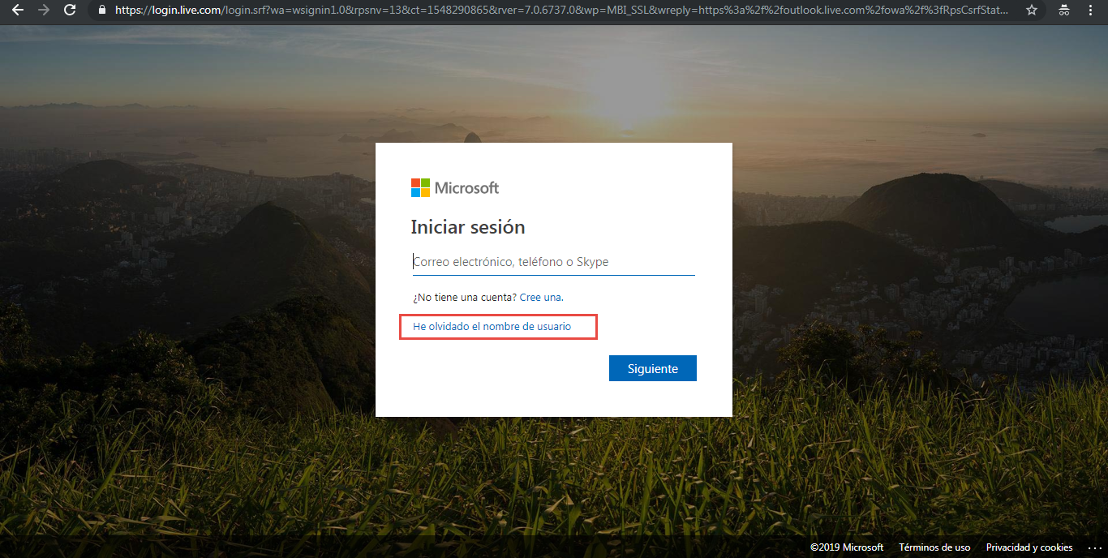<**a** **id**="forgotUsername" **data-bind**="

href: svr.AP,

text: str['WF_STR_ForgotUsernameLink_Text']" **href**="https://account.live.com/username/recover?wreply=https://login.live.com/login.srf%3flc%3d3082%26mkt%3dES-ES%26wa%3dwsignin1.0%26rpsnv%3d13%26ct%3d1548301768%26rver%3d7.0.6737.0%26wp%3dMBI_SSL%26wreply%3dhttps%253a%252f%252foutlook.live.com%252fowa%252f%253fnlp%253d1%2526RpsCsrfState%253d747d6c45-6159-5493-f726-38b9ba2091f0%26id%3d292841%26aadredir%3d1%26CBCXT%3dout%26lw%3d1%26fl%3ddob%252cflname%252cwld%26cobrandid%3d90015%26contextid%3dDC4666BA2EC4C92D%26bk%3d1548301768&amp;id=292841&amp;cobrandid=90015&amp;mkt=ES-ES&amp;lc=3082&amp;uiflavor=web">He olvidado el nombre de usuario</a>

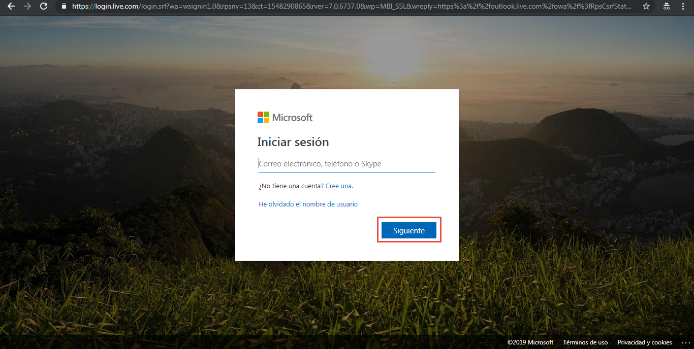

<**input type**="submit" **id**="idSIButton9" **class**="btn btn-block btn-primary" data-bind="

attr: {

'id': primaryButtonId || 'idSIButton9',

'aria-describedby': primaryButtonDescribedBy },

value: primaryButtonText() || str['CT_PWD_STR_SignIn_Button_Next'],

hasFocus: focusOnPrimaryButton,

click: primaryButton_onClick,

enable: isPrimaryButtonEnabled,

visible: isPrimaryButtonVisible,

preventTabbing: primaryButtonPreventTabbing" **value**="Siguiente">